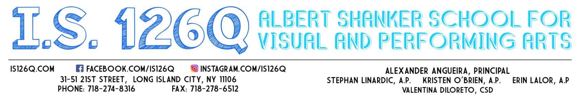
September 14, 2020

To the Parent/Guardian of (insert Student’s Name),

This letter is to inform you that your son/daughter (insert Student’s Name) has been placed in Cohort D based on your recorded preference for 100% remote learning as indicated on the New York City Department of Education Learning Preference Online Form. Please understand that by selecting 100% remote learning, your child will not be receiving any in-person classes within the IS 126 school building. Students in Cohort D will be receiving all of their instruction virtually. Some of the learning will be self-guided (asynchronous) while some instruction will be delivered synchronously via Zoom or Google Meets with the designated teacher and classmates. The schedule of your child’s synchronous lessons will be shared with you at the beginning of the school year. All NYC public school students are scheduled for remote learning from Wednesday, September 16thuntil Friday, September 18th during the hours of 10am to 12pm. Cohort D fully remote students will continue remote learning using this platform moving forward.
In order to comply with the safety protocols as outlined by the New York City Department of Education and CDC Guidelines, we must restrict the number of students/staff in our building at one time. Therefore, all students in cohort D will NOT be permitted entry in our school building. (The only students who will be allowed entry are those students who selected a blended learning model, and their access to the building will be determined by the cohort in which they are assigned). Your son/daughter are welcome to pick up grab and go breakfast & lunch daily during the hours of 8:30am-2:00pm. However, s/he will not be allowed to eat inside the school building.

Once the school year begins, should you wish to switch your child’s learning model from 100% remote learning to a blended learning model (two days in-person, two days remote and alternating Mondays), you may request such a switch only on a quarterly basis during a timeframe indicated by the DOE. (Based on our school’s model of 1B, Cohort A is in person Tuesdays & Wednesdays and alternating Mondays and Cohort B is in-person Thursdays & Fridays and alternating Mondays). All requests must be done online using the New York City Department of Education’s Learning Preference online form. The quarterly dates for you to request a switch from remote learning to blended learning have recently been announced by the New York City Department of Education. The quarterly dates as well as the link to the Learning Preference online form are posted on the NYCDOE’s website as well as on our school website www.is126q.com.

Wishing you and your family continued health and safety,

Alexander Angueira
Alexander Angueira
Principal

