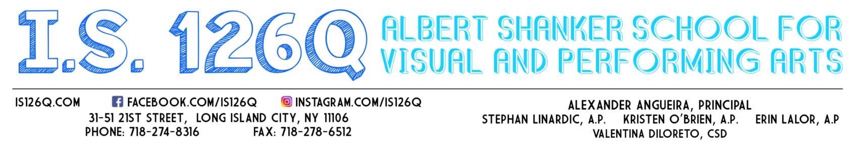
September 14, 2020

To the Parent/Guardian of (insert Student’s Name),

As previously shared with our school community, our school’s reopening model is 1B. Within that model, there are three cohorts:
- Cohort A – blended model consisting of in-person learning at IS 126 every Tuesday & Wednesday and alternating Mondays
- Cohort B – blended model consisting of in-person learning at IS 126 every Thursday & Friday and alternating Mondays
- Cohort D – 100% remote learning; no in-person learning at IS 126
This letter is to inform you that your son/daughter (insert Student’s Name) has been placed in Cohort A. A Spanish translated version of this letter can be found on the IS 126 website - www.is126q.com.

This placement was likely based on your recorded preference for blended learning as indicated on the New York City Department of Education Learning Preference Survey and/or on our IS 126 Survey. In the event that you did not respond to the surveys, your child was placed by the school in the cohort indicated above. Please note the following regarding the school’s use of data from the survey submissions in determining cohort placements:
- The default model is blended learning. Therefore, if you did not respond to either the New York City Department of Education survey or the IS 126 survey, your child was placed in either cohort A or B based on maintaining equal capacity.
- Consideration was also given to the grouping of students who receive state/federal mandated services (i.e. related services, ENL services).
- Considerable attempts were made to honor the requests of families who indicated a preference of cohort A or B on our 126 survey. In the instances where families completed our survey more than once, we followed the preference indicated in the most recent submission.
- Consideration was given to families who have more than one child registered in our school by placing known siblings in the same cohort.
- In the instances where families requested conflicting models on the New York City Department of Education survey and the IS 126 survey, the preference indicated on the New York City Department of Education’s official survey was used.

In a blended learning model, your child will be receiving set days of in-person classes within the IS 126 school building as well as set days of remote learning. During the remote learning portion, some of the learning will be self-guided (asynchronous) while some instruction will be delivered synchronously via Zoom or Google Meets. The schedule of your child’s synchronous lessons will be shared with you at the

beginning of the school year. All NYC public school students are scheduled for remote learning from Wednesday, September 16thuntil Friday, September 18th during the hours of 10am – 12pm. The first day of in-person learning at IS 126 for students assigned to blended learning cohort A will begin on Monday, September 21st.

In order to comply with the safety protocols as outlined by the New York City Department of Education and CDC Guidelines, we must restrict the number of students / staff in our building at one time. Therefore, students in cohort A will only be permitted in the building on their designated days of Tuesdays, Wednesdays and alternating Mondays. Cohort A students will NOT be permitted entry in our school building on Thursdays, Fridays or the Mondays designated for Cohort B. Your son/daughter is welcome to pick up a grab-and-go breakfast & lunch from the school between the hours of 8:30am-2:00pm on their designated remote learning days. However, s/he will not be allowed to eat inside the school building.
Should you wish to switch your child’s learning model from blended learning Cohort A to 100% remote learning (Cohort D), you may do so at any time. Families are required to complete the New York City Department of Education’s Learning Preference online form to indicate their selection for 100% remote. Please note that once placed in 100% remote learning, parents/guardians cannot immediately switch their child back into blended learning. Families can opt back into blended learning on a quarterly basis during a set timeframe three weeks before the quarter begins. The New York City Department of Education has recently announced those quarterly dates. You may find this information on the New York City Department of Education as well as on our school website www.is126q.com.

Should you wish to request a switch from blended learning Cohort A to blended learning Cohort B, we will do our best to accommodate your request but we cannot guarantee that the change will be made as we must limit our numbers in each cohort to maintain safety. Families have until Friday, August 28th to indicate their request on our internal IS 126 Blended Learning Cohort Change Request document. The link to the document is located on our school website www.is126q.com. You will be notified by a staff member, either in writing or by phone, regarding your request.

The IS 126 Administrative Team will be hosting a virtual Grade 6 Open House via Zoom on Monday, August 31 at 6:00pm and a virtual Town Hall for Grades 6, 7 & 8 via Zoom on Thursday, September 3 at 6:00pm. The links to those Zoom meetings will be posted on our school website. We look forward to having you join us at one or both of those meetings as we will be sharing pertinent information regarding our school’s reopening.
Wishing you and your family continued health and safety,
Alexander Angueira
Alexander Angueira
Principal

