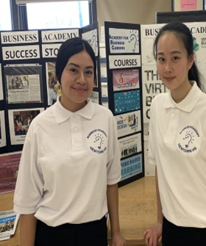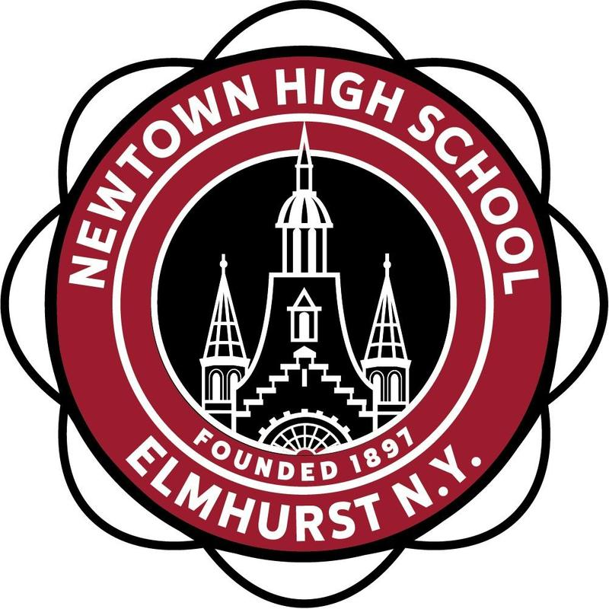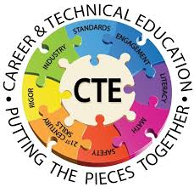

**Apply to our Business Academy Program with code: Q34A**

**Learn About our:**

* **Innovative Curriculum**
* **Paid Internships**
* **Business Simulations**
* **Industry and Busines Partnerships**
* **Recognize Industry Certifications**
* **College Credits Opportunities**
* **Scholarship Opportunities**

Newtown High School

New Media E- Commerce Virtual Recruitement Information Session!

When: Thursday, February 4, 2021 at 6:00 PM

Topic: New Media E-Commerce Business Program Information Session - Newtown High School

Time: Feb 4, 2021 06:00 PM

Join Zoom Meeting

https://us02web.zoom.us/j/89034845525?pwd=OVFKdlZoUjZDZTVuc242eGZyYWFqQT09

Meeting ID: 890 3484 5525

Passcode: 727287

Facilitators: Internship Coordinator, Madelyn Gonzalez, E, Nguyen and Business Students

For More Information on our Programs and How to Apply: Email: Mgonzalez11@schools.nyc.gov

+